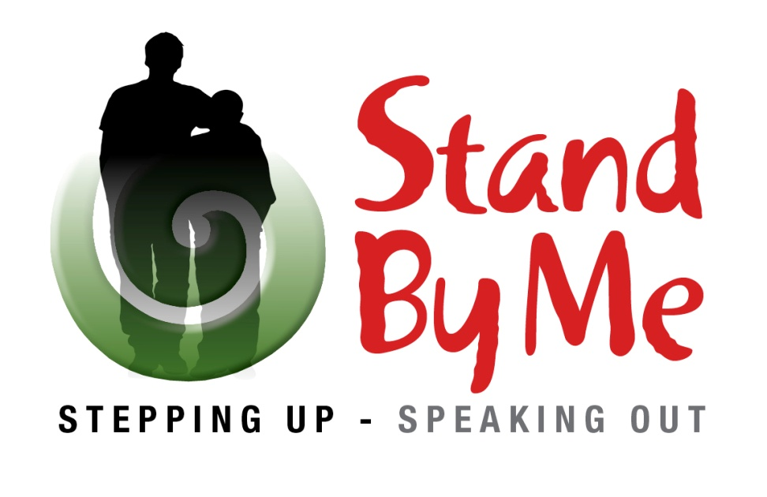

To all Children and Young People in the Hibiscus Coast,
This is to tell you about the: Stand By Me Safe Space at Orewa Library
Being launched: Friday the 23rd of May 2014 (Pink Shirt Day), from 3.30pm.
The Stand By Me Safe Space (just behind the main counter in the Library) is an area that you (our young people) can get information and support for any issues that you may be having (including bullying). An experienced person to help you will be present after school between 3.30 and 4.30. However you can access information or ask for help at the Orewa Library at anytime during opening hours.
Launch: Free cupcakes
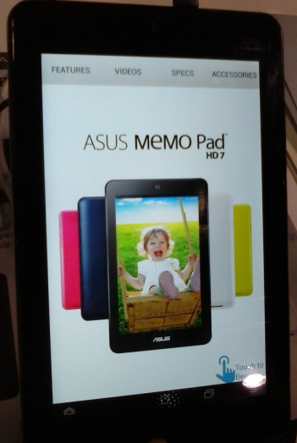
We are launching the Stand By Me Safe Space on Friday the 23rd May 2014 by giving away free to you and your friends 100 pink cupcakes in support of Pink Shirt Day. Wear pink as well and support this international anti bullying campaign.
Competition: Android Tablet Package worth $439.00 to be won.
Also enter the competition by filing in a very short questionnaire at the Stand By Me Safe Space. You could win an Asus MeMO Pad, a cover, a Razer Adaro In-Ear Headphones and a 32GB Class 10 Micro SDHC Flash Card, total package worth $439.00. (sponsored by Playtech and Z Service Stations). Competition finishes at 5pm on 20th June 2014.
We look forward to seeing you on Friday at the Orewa Library.
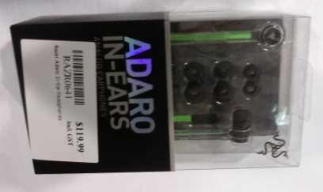
Cheers
Anna
Project Coordinator
North Shore Community and Social Services

