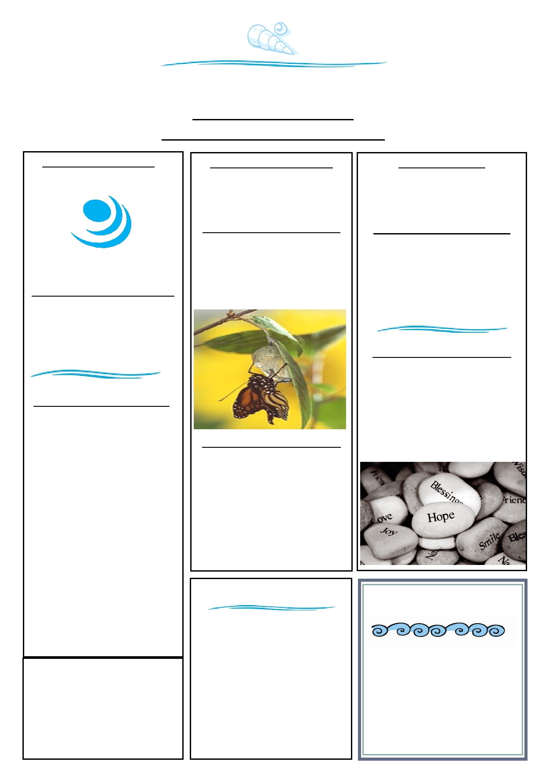Women's Centre Waitakere
COURSES FOR WOMEN
TERM 1, 2014 (JANUARY - APRIL)

KNOWING YOURSELF
Rebuilding Self-esteem

MONDAY: 10.00 - 12.00

START: 10th Feb - 31st March
(8 weeks)
@ Women's Centre Waitakere
111 McLeod Rd Te Atatu South

WHAT THE COURSE COVERS:

-What is self-esteem
- Developing self-esteem
- Parent, adult & child ego states
- Drama triangle - unhealthy patterns
of interactions within relationships
- Alternative triangle - stepping out of
the drama triangle
- Challenging destructive childhood
messages perceived as truth
-Explore Life positions - how these
influence our view of self and life
- What happens when our basic human needs are met/ not met
- Life Balance
- Exploring internal & external resources
- Setting SMART goals
- Self-care

Course Costs:
Weekly Gold Coin donation
Crèche: Available on request
Registration Essential!!

FAMILY RELATIONSHIPS
Creating a healthy family environment

WEDNESDAY: 10.00 - 12.30

START: 12th Feb - 2nd April
(8 weeks)
@ Dayspring Trust
2 Seabrook Ave
New Lynn

WHAT THE COURSE COVERS:

- What helps to create a healthy
family environment
- Exploring beliefs & values
- How to strengthen families
- How to strengthen relationships
- Love languages
- Attachment
- What behaviours & attitudes get in
the way

CONTACT US:

111 McLeod Rd, Te Atatu South
Tel: (09)838 6381
Mob: 021 196 6367

Email: info@womenscentre.org.nz
www.womenscentre.org.nz
Facebook us:
Women's Centre Waitakere

W.R.A.P. GROUP
Wellness Resilience Action Plan

FRIDAY: 10.00 - 1.00

START: 31st Jan - 7th March
(6 weeks)
@ Women's Centre Waitakere
111 McLeod Rd Te Atatu South
Limit of 10 participants

WHAT THE COURSE COVERS:

- Strategies to manage anxiety and
depression
- Develop a wellness recovery plan
around anxiety & depression

Developed in partnership with
Post Natal Distress Support Network

Mission statement

Empowering women
Promoting family wellbeing
and
Community belonging

