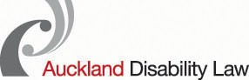

**People First New Zealand**

**Nga Tangata Tuatahi**

**Keeping Safe Feeling Safe Forum**

**Working together to end abuse of disabled adults**

**Stop: We have had enough**

**It’s time to take action**

Picture of a lightbulbThis is a chance for everyone to learn together about the abuse of disabled people in New Zealand, **in particular the abuse of people with learning/intellectual disabilities.**

**People First’s Aims:**

Picture of three people having a meetingTo bring together key people from health, DHBs, disability organisations, local and central government and people who are working in the violence prevention sector. We will explore how best to address the issue of abuse.

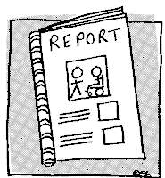

Action Plan

Participants will help make an action plan to stop the continuing abuse of disabled adults.

Picture of wax seal with RSVP embossed 

Limited spaces available, please RSVP by 14th August.

**When:** Wednesday 21st August 2013

**Forum: 10am to 12:30pm**

**(Morning tea available from 9.30am)**

Picture of a house**Where:** CCS Disability Action, 14 Erson Ave, Royal Oak, Auckland

Picture of a green racing car

Parking is available (limited parking in car park, additional parking on Erson Avenue). Unless you need mobility parking, please use the street.

Picture of a wheelchairAccess: Venue is wheelchair accessible. We will use a PA system. NZSL interpreters have been booked. Please let us know if you need the interpreters or have other access or dietary requirements by 14 August.

**Contact:** Kaeti Rigarlsford: 027 575 4000 or [kaeti@peoplefirst.org.nz](mailto:kaeti@peoplefirst.org.nz)