Professional Learning and Development Workshop
Auckland
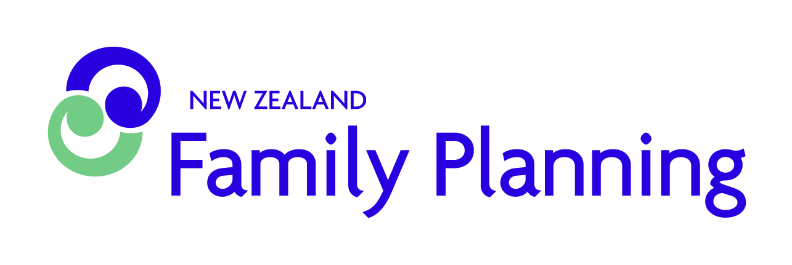

Family Planning supports communities and groups, schools, professionals and agencies with sexuality and relationships related education programmes, training and more. Our health promotion courses are suitable for teachers, teacher aides, community workers, nurses, health professionals, caregivers, aides, counsellors, social workers and youth workers.

Upcoming Workshop: Affirming Diversity

A one day workshop for teachers, nurses and community workers focused on teaching about sexual orientation and gender identity.

Description:
- Creating a safe and positive environment for addressing topics
- Importance of inclusiveness and identity affirming classroom practice
- Clarification of terminology and identities
- Tips on answering those tricky questions
- Lots of practical activities to use in the classroom
- Common myths and how to bust them

WHEN: | Friday 17 March 2017
TIME: | 8:30am - 4:30pm
WHERE: | Level 2, 5 Short Street, Newmarket
FACILITATOR: | Lesley-Ann Guild
COST: | $85.00 per person

Please note: Three working days notice of non-attendance is required.

Register online at www.familyplanning.org.nz/healthpromotionworkshops

Please email healthpromotionauckland@familyplanning.org.nz for further information.

