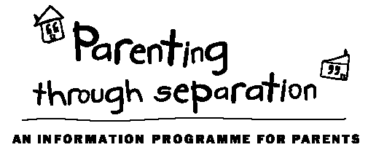 |  |  | Our facilitators  Griff Richards (Parenting Facilitator)  Griff facilitates the Early Years Toolbox, Building Awesome Whanau Toolbox on Tuesday evenings, the Tweens and Teens Toolbox, and all the Parenting Through Separation courses held at New Lynn.  818 0204 or griffr@lifewise.org.nz  About Lifewise Family Services  3131 Great North Rd, New Lynn  www.lifewise.org.nz  09 818 6834  In addition to parenting courses, we provide social work support in the following areas to families living in West Auckland:  - Parenting  - Advocacy  - Health/wellbeing  - Counselling  - Budgeting  - Housing  - Family relationships  - Family Violence  - Community Respite |  | Parenting Courses | 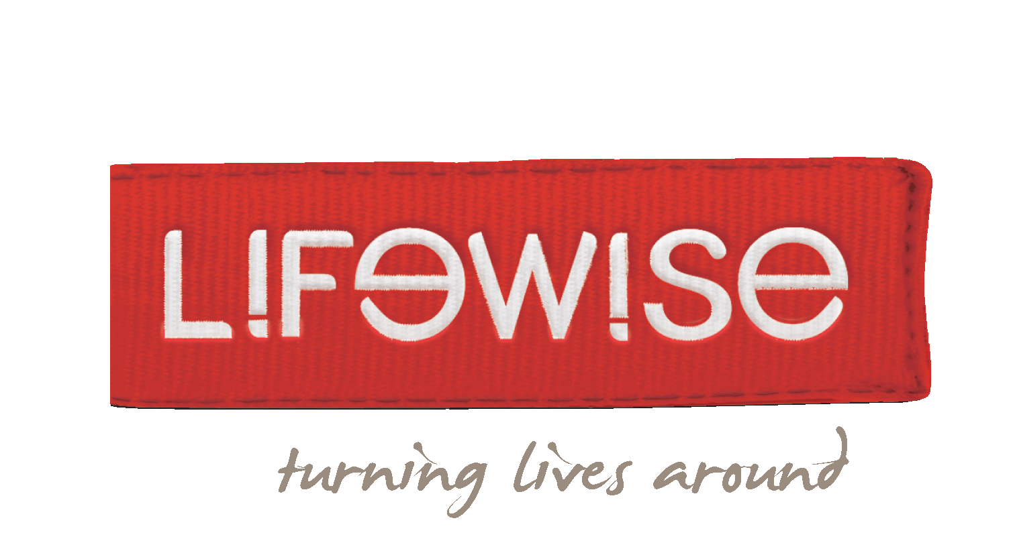  Toolbox Parenting Courses  &  Parenting Through Separation  TERM 2 - 2018  Lifewise Family Services  3131 Great North Rd, New Lynn
Parenting Through Separation
Separating from your partner or spouse is usually stressful, but the effects of this can be minimised for your children. This free, four-hour course provides a wealth of information and well-proven ideas that will benefit you and your children.
Dates
Thursday 15th March | 6pm – 10pm
Saturday 24th March | 10am - 2pm
Thursday 29th March | 6pm – 10pm
Saturday 31st March | 10am - 2pm
Saturday 14th April | 10am – 2pm
Thursday 19th April | 6pm – 10pm
Saturday 28th April | 10am - 2pm
Thursday 3rd May | 6pm – 10pm
Saturday 12th May | 10am - 2pm
Thursday 17th May | 6pm – 10pm
Saturday 26th May | 10am - 2pm
Thursday 31st May | 6pm – 10pm

Cost
This course is fully funded by the Ministry of Justice and there is no cost to you.
Register
To register or for more information, contact Jess Hale
ph. 818 6834, email jessh@lifewise.org.nz
Venue
Lifewise Family Services,
3131 Great North Rd,
New Lynn
Toolbox Courses Cost
Sliding scale from gold coin donation up to full cost $75/person or $110/couple. FREE to foster parents and caregivers.
Early Years  (0-6 years)  Topics  - Different parenting styles  - The style that works best  - Physical and emotional needs  - Children’s personality types  - Different ages and stages  - How to engage cooperation  - Handling more difficult behaviour  - The strong-willed child  - Creating a childhood to remember  - The Five Love Languages  Dates  Monday evenings for six weeks  7pm – 9.15pm  30th April 2018 to 4th June 2018 |  |  | Building Awesome Whanau  (0-12 years)  Topics  - Building your family on aroha  - Parents are the roof: protecting your whanau  - The walls of the whare: boundaries to keep the good stuff in and the bad stuff out  - Keep it sweet: atmosphere is everything  - Cool korero: communication  - Outside the whare: living in the big world  Dates  Tuesday evenings for six weeks  7pm – 9.15pm  1st May 2018 to 5th June 2018 |  |  | Tweens & Teens  (12 years +)  Topics  - What makes a teenager tick  - Creating a positive atmosphere  - Teenagers and chores  - Limits and boundaries  - Keeping them connected to family  - Communication with your teenager  - Age appropriate consequences  - What about sex and dating?  - Keeping your teenager safe  - From discipline to self-discipline  Dates  Wednesday evenings for six weeks  7pm – 9.15pm  2nd May 2018 to 6th June 2018
To register or more information:
ph: 818 6834 email: familyservices@lifewise.org.nz web: www.lifewise.org.nz

