 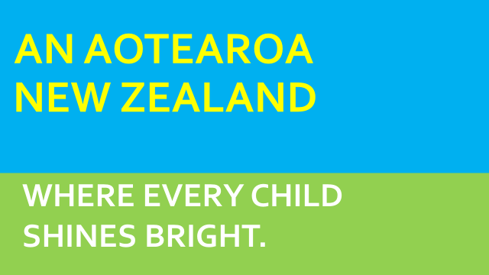

**Barnardos North West Auckland**

What We Can Offer Families

* **LEAP** is a new Barnardos service to help vulnerable families better meet the needs of their children so they can reach their potential.
* Parenting Programmes in the home – Toolbox or Triple P
* Parenting Through Separation
* Footsteps to Feeling Safe-our programme for children who have witnessed Family Violence (group or individuals)
* Strengthening Families (facilitation)
* Home For Life-in conjunction with our Foster Care Services
* HIPPY- Royal Heights only
* Children’s Supervised Contact - West only
* Intensive Wrap Around Service (MoE) new programme - South and Central
* Women’s Safety Programme - West only
* **In many cases we are able to offer a mix of these as they suit the child and family need**

Referrals:

Can be made by email-please contact us to get an electronic referral sent to you

Please phone if you would like to discuss a referral:

Sharyn Chow

Service Manager

Ph: 6253675 or 0272371436

E: [sharyn.chow@barnardos.org.nz](mailto:sharyn.chow@barnardos.org.nz)

