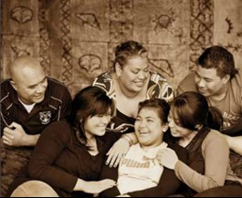

Vaka Pasifika:
Vaka Pasifika offer social support services in the West Auckland area, such support includes but not limited to:
- Parenting - Discipline, Neglect, Emotional/Psychological abuse
- Anger Management - Domestic / Family Violence
- Relationships
- Family Support

In addition to our anger management program To'a I' Loto for Pacific Men we also offer Fisi and Anger Management program for Women

Anglican Trust for Women and Children:
The Anglican Trust for Women and Children provide support in the South and Central Auckland areas as well as the North Shore. Other services that are relevant include:
- Residential parenting programs
- Family Start
- Mellow Parenting
- Social Work Support

10 Beatty St
Otahuhu
Auckland 1062
Phone Number 09 276 3729
Fax Number 09 276 9761
Email info@atwc.org.nz

TO’A I' LOTO 'Strength Within'

Anger Management Programme for Pacific Men

Contact Details:
53 Chislehurst Street, Henderson, Auckland.
Phone: 021 029 00701
Email: info@vakapasifika.org.nz
www.vakapasifika.org.nz
Advancing Social Services for Pacific Peoples

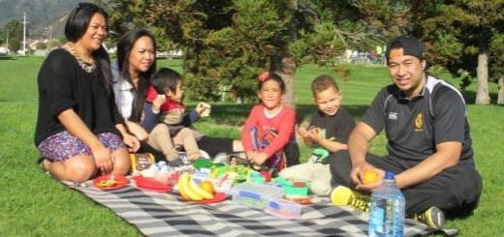

The To’a I loto Anger Management program is a twelve-week program working with Pacific men with dependents. The program aims to address violent behaviours towards their partners, children and/or others.

To’a ‘I loto is specifically designed to cater to Pacific Island Men with anger issues. Topics delivered in our program is based on Identity, Family dynamics, Responsibility, Accountability and Assimilating to living in New Zealand. In addition, the program also covers the legal implications of their behaviour. Our 12-week group program is followed with a three month follow up to gauge and support the men's progress. We believe that the content in our program as well as the 3-month follow up will encourage positive change for the participants and their families.
Upon receiving the referral, the men will be contacted to complete an assessment. The assessment is to ensure the men are in-line with the referral criteria, ensure the programme is a good fit for them and to flush out any issues that could get in the way of their learning.
A total of four evaluations will be conducted. The initial evaluation will be based on their current level of understanding (this is done at assessment phase). The second evaluation will be at the end of the twelve-week delivery period where the evaluation will gauge the participants progress/change from the initial evaluation. The third evaluation is the final evaluation for the participants which will be conducted at the end of the three month follow up. The fourth and final evaluation will be conducted with the partners of the participants to gauge whether the participants have made positive changes in their behaviour.

Programme Details:
Once a week – 2hour sessions
7pm – 9pm
Light refreshments provided
Pacific Facilitator with guest speakers.
Venue – West Auckland and Upper Harbour
FREE Programme

Delivery mechanism:
Role play (scenarios), Discussion, feedback/evaluation, face to face sessions, videos, guest speakers.

To make a referral:
Please email us on info@vakapasifika.org.nz
Or
Phone 02102900701

