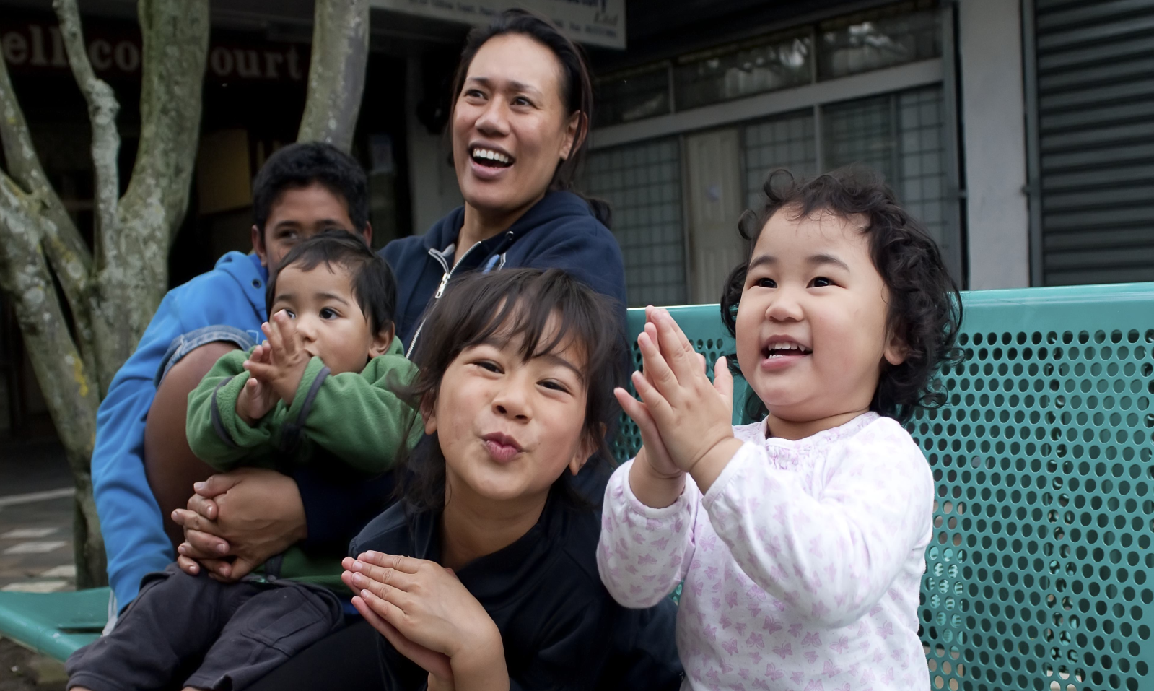
The INCREDIBLE YEARS
DO YOU NEED SUPPORT TO BE THE BEST PARENT YOU CAN BE?
The Incredible Years is a proven parenting programme that gives New Zealand families the confidence to succeed. It’s for parents of children aged 3-8 years and involves weekly sessions for 14 weeks.  Over the weeks, parents develop strategies to build positive relationships with their children and manage unwanted behaviours like aggressiveness, tantrums, swearing, yelling, hitting, answering back and refusing to do as asked.  These behaviours cause enormous family stress and parents can feel alone and helpless. But positive and harmonious family life is possible. | Topics include:  • how to play / spend time together  • praising and rewarding children  • communicating positively  • dealing with disobedience, ignoring, time-out and other appropriate consequences  • helping children to problem-solve  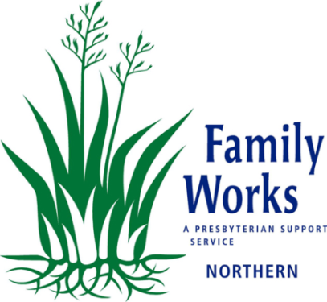  The Incredible Years is a group programme where parents come together each week, talk through what has and hasn’t worked, set goals and learn ways to achieve those goals during the following week.
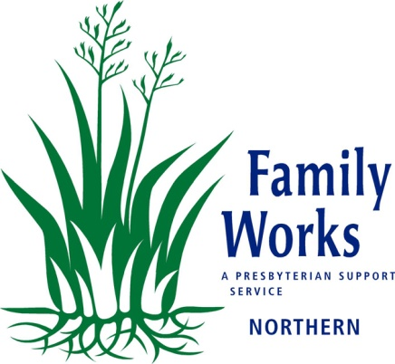
PROGRAMME DETAILS
Wednesdays, starting 7 March 2018, 9.30am to 12 noon
At Family Works, 3 Montel Ave, Henderson
To book please call 09 835 1288
or email Admin.Waitakere@fwn.org.nz
Enquiries: stephanie.hills@fwn.org

