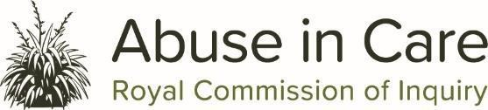

Join us for a hui about the Abuse in Care Inquiry

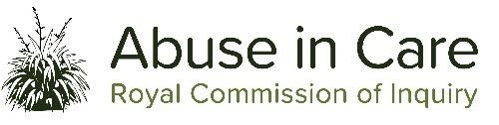
This hui is for people from and part of the Learning disability, neurodiversity and cognitive impairment community to find out about the Abuse in Care Inquiry.

At the hui we will talk about:
- why the Inquiry was set up

- what the Inquiry does

- how people can share their story with the Inquiry.

We know that talking about abuse can be upsetting.
There will be a wellbeing person if you need them on the day.

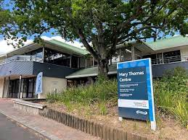
When: Tuesday 15th June 2021
Time: 10.00am – 12.30pm
Where: Mary Thomas Centre,
3 Gibbons Road, Takapuna,
Auckland 0740

Please let us know if you have any:
- accessibility needs

- dietary needs (for morning tea).

Tell us if you can come by 8 June on disability@abuseincare.org.nz
Or

You can contact Loren Savage with any questions Mobile: 027 301 2714

Nā tō rourou, nā taku rourou ka ora ai te iwi
With your food basket and my food basket the people will thrive

