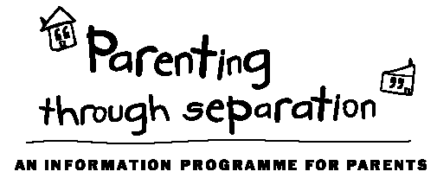 |  |  | Our facilitators  Griff Richards (Parenting Facilitator)  Griff facilitates the Baby & Toddler Years Toolbox, the Building Awesome Whanau Toolbox on Tuesday evenings, the Teenage Toolbox, and all the Parenting Through Separation courses held at New Lynn.  818 0204 or griffr@lifewise.org.nz  Bella Wikaira (Community Social Worker)  Bella facilitates the Building Awesome Whanau Toolbox on Thursday mornings.  818 0202 or bellaw@lifewise.org.nz  About Lifewise Family Services  3131 Great North Rd, New Lynn  www.lifewise.org.nz  09 818 6834  In addition to parenting courses, we provide social work support in the following areas to families living in West Auckland:  - Parenting  - Advocacy  - Health/wellbeing  - Counselling  - Budgeting  - Housing  - Family relationships  - Family Violence  - Community Respite |  | Parenting Courses | 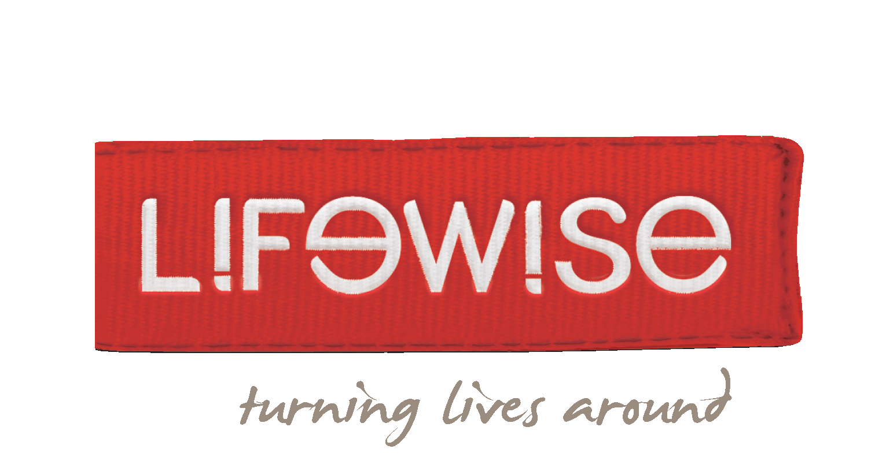  Lifewise Family Services  3131 Great North Rd, New Lynn  Toolbox Parenting Courses  &  Parenting Through Separation  TERM 3 - 2018
Parenting Through Separation
Separating from your partner or spouse is usually stressful, but the effects of this can be minimised for your children. This free, four-hour course provides a wealth of information and well-proven ideas that will benefit you and your children.
Dates:
Saturday 9th June | 10am – 2pm
Thursday 14th June | 6pm – 10pm
Saturday 23rd June | 10am – 2pm
Thursday 28th June | 6pm – 10pm
Saturday 30th June | 10am-2pm
*Helensville location
Saturday 7th July | 10am - 2pm
Thursday 12th July | 6pm – 10pm
Saturday 21st July | 10am – 2pm
Thursday 26th July | 6pm – 10pm
Saturday 4th August | 10am - 2pm
Thursday 9th August | 6pm – 10pm
Saturday 18th August | 10am - 2pm
Thursday 23rd August | 6pm – 10pm
Saturday 1st September | 10am - 2pm
Thursday 6th September | 6pm – 10pm
Saturday 15th September | 10am - 2pm
Thursday 20th September | 6pm – 10pm
Cost: This course is fully funded by the Ministry of Justice and there is no cost to you.
Register:
To register or for more information, contact Jess Hale - ph. 818 6834, email jessh@lifewise.org.nz
Venue
Lifewise Family Services,
3131 Great North Rd,
New Lynn
Toolbox Courses Cost
Cost is $75/person or $110/couple. There is a subsidy available for financial hardship.
Baby and Toddler Years  (0-5 years)  Topics  - Love is the foundation  - Parents  - Stronger, deeper, closer  - Heart-led parenting  - Discipline without shouting, force, fluster  - Putting it all together  Dates  Monday evenings for six weeks  7pm – 9.15pm  30th July 2018 to 3rd Sept 2018 |  |  | Building Awesome Whanau  (0-12 years)  Topics  - Building your family on aroha  - Parents are the roof: protecting whanau  - The walls of the whare : boundaries  - Keep it sweet: atmosphere is everything  - Cool korero: communication  - Outside the whare: living in the big world  Dates  Tuesday evenings for six weeks  7pm – 9.15pm  31st July 2018 to 4th Sept 2018  OR  Thursday mornings for six weeks  10am – 12.15pm  2nd August 2018 to 6th Sept 2018 |  |  | Teenage Years  (13+ years)  Topics  - Love is the foundation  - Parents  - Stronger, deeper, closer  - Heart-led parenting  - Discipline without shouting, force, fluster  - Putting it all together  Dates  Wednesday evenings for six weeks  7pm – 9.15pm  1st August 2018 to 5th Sept 2018
To register or more information:
ph: 818 6834 email: familyservices@lifewise.org.nz web: www.lifewise.org.nz

