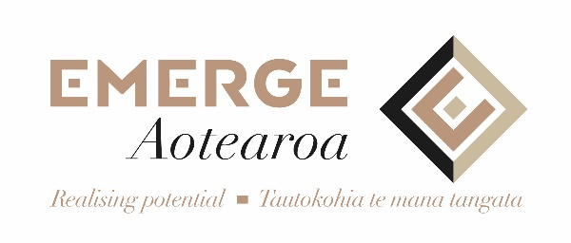
Family/ Whānau Support Services
Waitemata District

ARE YOU NEEDING SUPPORT?
We are a free service that focuses on supporting family/ whānau who have a loved one experiencing mental health distress.
At Emerge Aotearoa, we understand the important roles family/whānau can have in the recovery of their loved one.

OUR FREE SERVICE PROVIDES

SUPPORT
On your health & wellbeing,
How to best care and support your loved one with mental health distress.

INFORMATION/ EDUCATION
To have a better understanding of mental health illnesses, services and supports.

ADVOCACY
To empower family/whānau to confidently navigate mental health services.

Family/whānau Support Worker
Martina Gifford
DDI 09 839 7308 P 09 839 7301 M 021 847 206
martina.gifford@emergeaotearoa.org.nz

