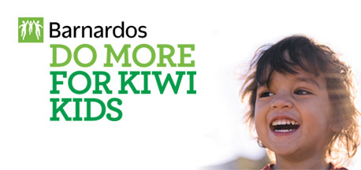

HIPPY Coordinator
About the business
The programme content is provided by the Great Potentials Foundation to assist parents to prepare their child for school – particularly where there have been challenges with other early childhood education.
About the role
The role is responsible for ensuring continued recruitment and retention of families on to the programme. The work is rewarding and fits with Barnardos vision to make New Zealand a better, safer, happier place for Kiwi kids.
Benefits and perks
- Family friendly organisation with flexible working.
- Reduced cost childcare and other benefits
- Professional and supportive colleague
Skills and experience
To excel in this role, you will need
- a tertiary qualification in a relevant field or experience working in a similar community programme – although full training/regular supervision will be provided
- to be self-motivated and able to work autonomously
- the ability to lead and provide quality mentoring to the team
- the ability to relate to families in need while also representing Barnardos and HIPPY in the wider community
- excellent planning and organisational skill
Barnardos is New Zealand's leading children's charity. We tailor our services to respond to local needs, individual challenges and diverse experiences.
We're here for all Kiwi kids. Every day, our services and staff make a real and positive difference in the lives of thousands of children and families across New Zealand.
With your help, we can do even more.
To view the position description please visit - https://www.barnardos.org.nz/work-for-us/
For more information please contact Lesley Macken Lesley.macken@barnardos.org.nz
Applications close 12th February
Please only apply for this role if you are eligible to work in New Zealand.

