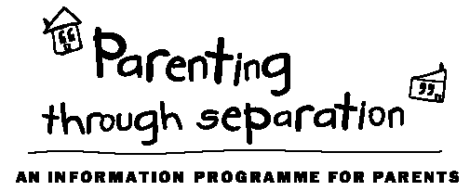 |  |  | Our facilitators  Griff Richards (Parenting Facilitator)  Griff facilitates the Baby & Toddler Years Toolbox, the Building Awesome Whanau Toolbox on Tuesday evenings, the Teenage Toolbox, and all the Parenting Through Separation courses held at New Lynn.  818 0204 or griffr@lifewise.org.nz  Bella Wikaira (Community Social Worker)  Bella facilitates the Building Awesome Whanau Toolbox on Thursday mornings.  818 0202 or bellaw@lifewise.org.nz  About Lifewise Family Services  3131 Great North Rd, New Lynn  www.lifewise.org.nz  09 818 6834  In addition to parenting courses, we provide social work support in the following areas to families living in West Auckland:  - Parenting  - Advocacy  - Health/wellbeing  - Counselling  - Budgeting  - Housing  - Family relationships  - Family Violence  - Community Respite |  | Parenting Courses | 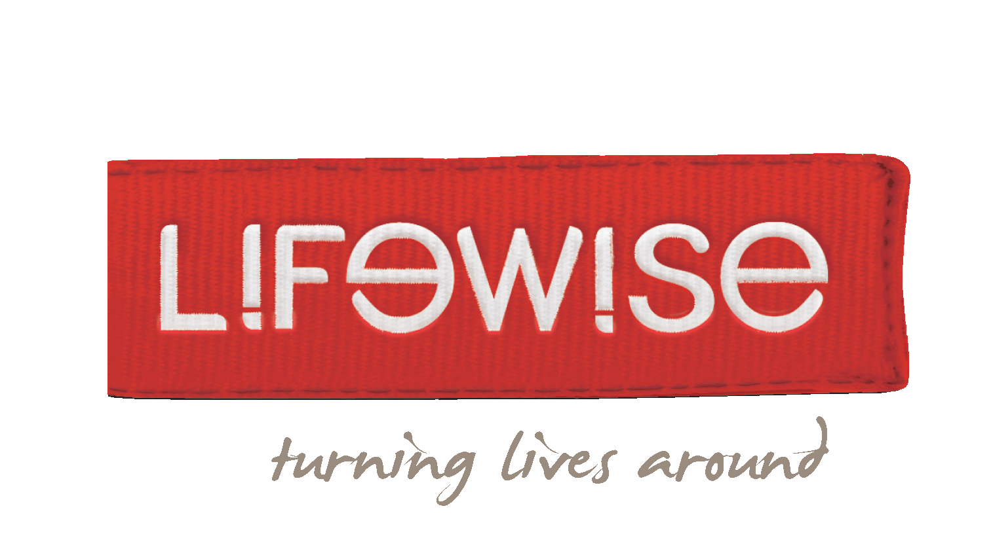  Lifewise Family Services  3131 Great North Rd, New Lynn  Toolbox Parenting Courses  &  Parenting Through Separation  TERM 4 - 2018
Parenting Through Separation
Separating from your partner or spouse is usually stressful, but the effects of this can be minimised for your children. This free, four-hour course provides a wealth of information and well-proven ideas that will benefit you and your children.
Dates:
Saturday 29th Sept | 10am – 2pm
Thursday 4th Oct | 6pm – 10pm
Saturday 13th Oct | 10am – 2pm
Thursday 18th Oct | 6pm – 10pm
Saturday 27th Oct | 10am - 2pm
Thursday 1st Nov | 6pm – 10pm
Saturday 10th Nov | 10am – 2pm
Thursday 15th Nov | 6pm – 10pm
Saturday 24th Nov | 10am - 2pm
Thursday 29th Nov | 6pm – 10pm
Saturday 8th Dec | 10am - 2pm
Thursday 13th Dec | 6pm – 10pm
Saturday 22nd Dec | 10am - 2pm
Thursday 17th Jan | 6pm – 10pm
Saturday 26th Jan | 10am - 2pm
Thursday 31st Jan | 6pm – 10pm
Cost: This course is fully funded by the Ministry of Justice and there is no cost to you.
Register:
To register or for more information, contact Jess Hale - ph. 818 6834, email jessh@lifewise.org.nz
Venue
Lifewise Family Services,
3131 Great North Rd,
New Lynn
Toolbox Courses Cost
Cost is $75/person or $110/couple. There is a subsidy available for financial hardship.
Baby and Toddler Years  (0-5 years)  Topics  - Love is the foundation  - Parents  - Stronger, deeper, closer  - Heart-led parenting  - Discipline without shouting, force, fluster  - Putting it all together  Dates  Monday evenings for six weeks  7pm – 9.15pm  15th Oct 2018 to 19th Nov 2018 |  |  | Building Awesome Whanau  (0-12 years)  Topics  - Building your family on aroha  - Parents are the roof: protecting whanau  - The walls of the whare : boundaries  - Keep it sweet: atmosphere is everything  - Cool korero: communication  - Outside the whare: living in the big world  Dates  Tuesday evenings for six weeks  7pm – 9.15pm  16th Oct 2018 to 20th Nov 2018  OR  Thursday mornings for six weeks  10am – 12.15pm  18th Oct 2018 to 22nd Nov 2018 |  |  | Teenage Years  (13+ years)  Topics  - Love is the foundation  - Parents  - Stronger, deeper, closer  - Heart-led parenting  - Discipline without shouting, force, fluster  - Putting it all together  Dates  Wednesday evenings for six weeks  7pm – 9.15pm  17th Oct 2018 to 21st Nov 2018
To register or more information:
ph: 818 6834 email: familyservices@lifewise.org.nz web: www.lifewise.org.nz

