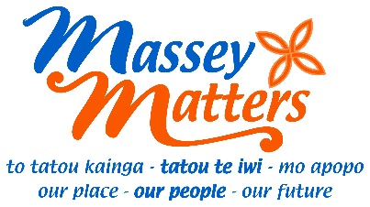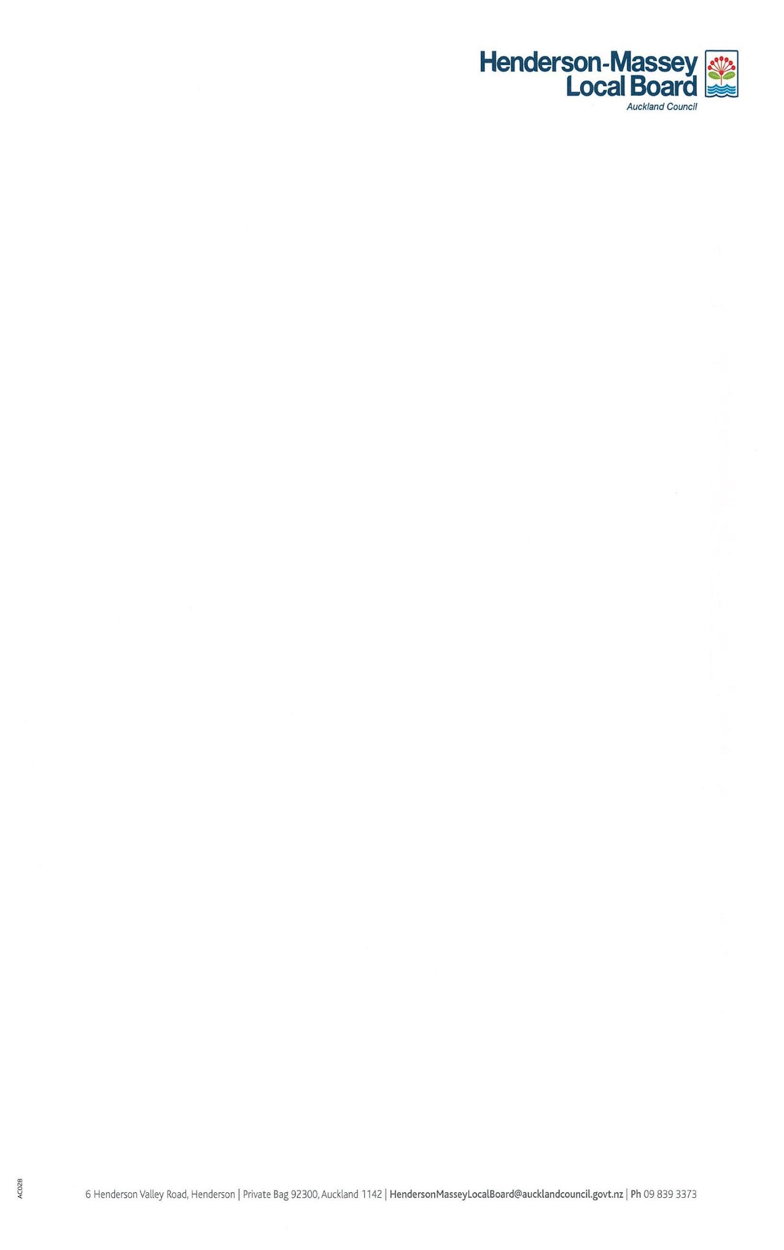

**MASSEY MATTERS INCOPORATED**

**Cordially Invites You to Our**

# **ANNUAL GENERAL MEETING**

**Tuesday 15th November**

**6:00 p.m. to 7.30 p.m.**

**Manutewhau Community Hub**

**74b Oreil Ave, West Harbour**

**The purpose of this meeting is to elect a new governance board and present the annual reports.**

**Formal proceedings will be followed with nibbles prepared by our Boost leadership programmes ladies.**

**Please RSVP for catering purposes to**

[**admin@maseymatters.org.nz/**](mailto:admin@maseymatters.org.nz/) **ph: 09 832 0431**

**Mob: 022 658 178**





