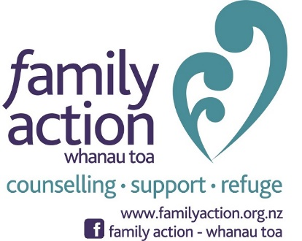

Take Action Campaign

We want to know how YOU take action in your life, community, or workplace to make your world a better place.

Family Action is planning a photo campaign. The campaign focus is on how individuals take action in their lives, community, or workplace to make their world a better place. The purpose of this campaign is to inspire others to take action in their communities and at the very least, to recognise the good in the world and bring a little faith in humanity back to the community.

Family Action will obtain thirty photos of volunteers with captions about their lives, which will then be published online throughout the month of November; particularly on Instagram and Facebook.

There will be a photo release agreement signed by the photo subject for each photo released by Family Action. There is also the potential for an exhibition in West Auckland if the campaign is a success.

During the month the public will be encouraged to post their own photos, and Tag Family Action in their own posts. By using #TakeAction in their description, the photos will all be logged to an Instagram gallery.

