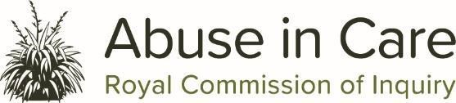

Join us for a hui about the Abuse in Care Inquiry

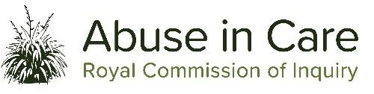
This hui is for people with a learning disability to find out about the Abuse in Care Inquiry.

At the hui we will talk about:
- what abuse and neglect means

- who to tell if it has happened to you

- what you think helps people feel safe to speak up.

We know that talking about abuse can be upsetting.
There will be a wellbeing person if you need them on the day.

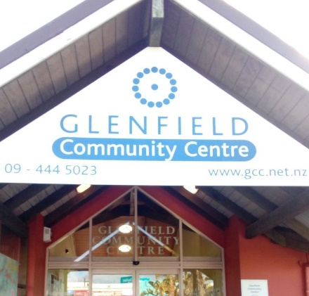
When: Tuesday 6th July 2021
Time: 10.00am – 12.30pm
Where: Glenfield Community Centre,
Corner of Bentley Avenue and
Glenfield Road, Glenfield,
Auckland 0747

Please let us know if you have any:
- accessibility needs

- dietary needs (for morning tea and lunch).

Tell us if you can come by 2 July on disability@abuseincare.org.nz
Or

You can contact Loren Savage with any questions Mobile: 027 301 2714

Nā tō rourou, nā taku rourou ka ora ai te iwi
With your food basket and my food basket the people will thrive

